**Monitor User Commands:**

Following are the basic user monitor commands

* who
* last
* w
* id

**who**

As a Linux user, sometimes it is required to know some basic information like :

* Time of last system boot
* List of users logged-in
* Current run level etc

Though this type of information can be obtained from various files in the Linux system but there is a command line utility 'who' that does exactly the same for you. In this article, we will discuss the capabilities and features provided by the 'who' command.   
  
The basic syntax of the who command is :

who [OPTION]... [ FILE | ARG1 ARG2 ]

**Examples of 'who' command**

**1. Get the information on currently logged in users**

This is done by simply running the 'who' command (without any options). Consider the following example:

$ who

iafzal tty7 2012-08-07 05:33 (:0)

iafzal pts/0 2012-08-07 06:47 (:0.0)

iafzal pts/1 2012-08-07 07:58 (:0.0)

**2. Get the time of last system boot**

The is done using the -b option. Consider the following example:

$ who -b

system boot 2012-08-07 05:32

So we see that the above output gives the exact date and time of last system boot.

**3. Get information on system login processes**

This is done using the -l option. Consider the following example:

$ who -l

LOGIN tty4 2012-08-07 05:32 1309 id=4

LOGIN tty5 2012-08-07 05:32 1313 id=5

LOGIN tty2 2012-08-07 05:32 1322 id=2

LOGIN tty3 2012-08-07 05:32 1324 id=3

LOGIN tty6 2012-08-07 05:32 1327 id=6

LOGIN tty1 2012-08-07 05:32 1492 id=1

So we see that information related to system login processes was displayed in the output.

**4. Get the hostname and user associated with stdin**

This is done using the -m option. Consider the following example:

$ who -m

iafzal pts/1 2012-08-07 07:58 (:0.0)

So we see that the relevant information was produced in the output.

**5. Get the current run level**

This is done using the -r option. Consider the following example:

$ who -r

run-level 2 2012-08-07 05:32

So we see that the information related to current run level (which is 2) was produced in the output.

**6. Get the list of user logged in**

This is done using the -u option. Consider the following example:

$ who -u

iafzal tty7 2012-08-07 05:33 old 1619 (:0)

iafzal pts/0 2012-08-07 06:47 00:31 2336 (:0.0)

iafzal pts/1 2012-08-07 07:58 . 2336 (:0.0)

So we see that a list of logged-in users was produced in the output.

**7. Get number of users logged-in and their user names**

This is done using the -q option. Consider the following example:

$ who -q

iafzal iafzal iafzal

# users=3

So we see that information related to number of logged-in users and their user names was produced in the output.

**8. Get all the information**

This is done using the -a option. Consider the following example:

$ who -a

system boot 2012-08-07 05:32

run-level 2 2012-08-07 05:32

LOGIN tty4 2012-08-07 05:32 1309 id=4

LOGIN tty5 2012-08-07 05:32 1313 id=5

LOGIN tty2 2012-08-07 05:32 1322 id=2

LOGIN tty3 2012-08-07 05:32 1324 id=3

LOGIN tty6 2012-08-07 05:32 1327 id=6

LOGIN tty1 2012-08-07 05:32 1492 id=1

iafzal + tty7 2012-08-07 05:33 old 1619 (:0)

iafzal + pts/0 2012-08-07 06:47 . 2336 (:0.0)

iafzal + pts/1 2012-08-07 07:58 . 2336 (:0.0)

So we see that all the information that 'who' can print is produced in output.

**last command:**

To find out when a **particular user last logged in** to the Linux or Unix server.

## Syntax

The basic syntax is:

last  
last [userNameHere]  
last [tty]  
last [options] [userNameHere]

If no options provided last command displays a list of all users logged in (and out). You can filter out results by supplying names of users or terminal to show only those entries matching the username/tty.

## last command examples

To find out who has recently logged in and out on your server, type:  
$ last   
Sample outputs:

|  |
| --- |
| root pts/1 10.1.6.120 Tue Jan 28 05:59 still logged in  root pts/0 10.1.6.120 Tue Jan 28 04:08 still logged in  root pts/0 10.1.6.120 Sat Jan 25 06:33 - 08:55 (02:22)  root pts/1 10.1.6.120 Thu Jan 23 14:47 - 14:51 (00:03)  root pts/0 10.1.6.120 Thu Jan 23 13:02 - 14:51 (01:48)  root pts/0 10.1.6.120 Tue Jan 7 12:02 - 12:38 (00:35)    wtmp begins Tue Jan 7 12:02:54 2014 |

### 

### List all users last logged in/out time

last command searches back through the file /var/log/wtmp file and the output may go back to several months. Just use the less command or more command as follows to display output one screen at a time:  
$ last | more  
last | less

### List a particular user last logged in

To find out when user iafzal last logged in, type:  
$ last iafzal  
$ last iafzal | less  
$ last iafzal | grep 'Thu Jan 23'

Sample outputs:

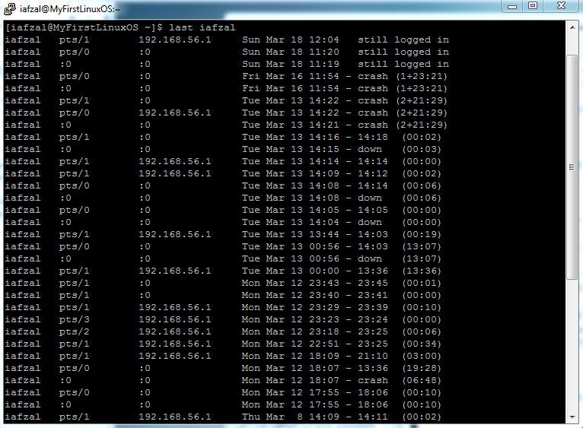

### 

### Hide hostnames (Linux only)

To hide the display of the hostname field pass -R option:  
$ last -R  
last -R iafzal  
Sample outputs:

|  |
| --- |
|  |

### Display complete login & logout times

By default year is now displayed by last command. You can force last command to display full login and logout times and dates by passing -F option:  
$ last -F  
Sample outputs:

|  |
| --- |
|  |

### Display full user/domain names

$ last -w

### Display last reboot time

The user reboot logs in each time the system is rebooted. Thus following command will show a log of all reboots since the log file was created:  
$ last reboot  
$ last -x reboot

### Display last shutdown time

Find out the system shutdown entries and run level changes:  
$ last -x  
$ last -x shutdown

### Find out who was logged in at a particular time

The syntax is as follows to see the state of logins as of the specified time:  
$ last -t YYYYMMDDHHMMSS  
$ last -t YYYYMMDDHHMMSS userNameHere

**w command:**

Options:

-h, --no-header do not print header

-u, --no-current ignore current process username

-s, --short short format

-f, --from show remote hostname field

-o, --old-style old style output

-i, --ip-addr display IP address instead of hostname (if possible)

--help display this help and exit

-V, --version output version information and exit

**id command:**

Print user and group information for the specified USER,

or (when USER omitted) for the current user.

-a ignore, for compatibility with other versions

-Z, --context print only the security context of the current user

-g, --group print only the effective group ID

-G, --groups print all group IDs

-n, --name print a name instead of a number, for -ugG

-r, --real print the real ID instead of the effective ID, with -ugG

-u, --user print only the effective user ID

-z, --zero delimit entries with NUL characters, not whitespace;

not permitted in default format

--help display this help and exit

--version output version information and exit